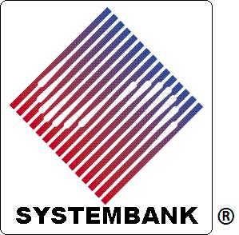 | 
Systembank® Credit Billing Services
Systembank® Credit Billing Services is a streamlined and cost-effective means to electronically manage transaction billing and payments for internal Systembank® Credit Invoices, as well as for external clients utilizing our billing services.
To make a payment for a Systembank® Credit Invoice, please pay by major credit card using our Merchant Services Account.
Visa, MasterCard, Discover Card and American Express credit cards are welcome as form of payment.
To establish a "Signature On File" account, for recurring payments, unknown amounts, or remote locations, please:
- a) Save this file to your computer,
- b) Complete and re-save this file to your computer for your records, and
- c) E-mail the file back to us with your authorization to open an account. You shall be contacted shortly.
- Non-swipped transactions require a 4% Billing Fee, which covers the Merchant Fee, as charged by our intermediary bank.

U.S. Dollar Amount:

If Fixed Amount, Specify Exact U.S. Dollar Amount Authorized:

Credit Card Type:

Credit Card Number:

Expiration Month:

Expiration Year:

Cardholder Billing Name (As Appears On Card):

Card Security Code:

This is a Business Corporate Card.

Cardholder Billing Street Address & City:

Cardholder Billing Zip Code:

SBC Invoice Number(s) or Special Instructions for Processing:

Important: Please save this file to your computer for your records, and e-mail to admin@systembank.net for processing.

We sincerely appreciate the opportunity to serve you. Thank you for using Systembank® Credit Billing Services.
Please contact Steve Lewis at admin@systembank.net for information on how Systembank® Credit Billing Services can manage transactions for your small business!
The SYSTEMBANK® name and logo are registered trademarks with the U.S. Patent and Trademark Office. All rights reserved.

